**Create patterns by nested loops**

By using nested loops you can create different shapes of patterns, like square, rectangle, pyramid shape, and created pattern of repeated numbers.

**Example:** on repeated number pattern:

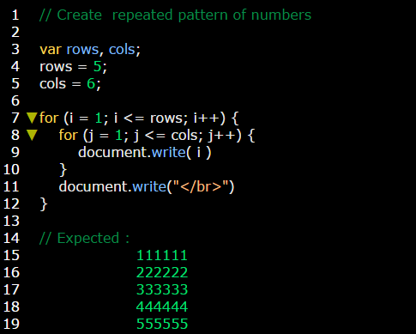

**Example:** on rectangle pattern:

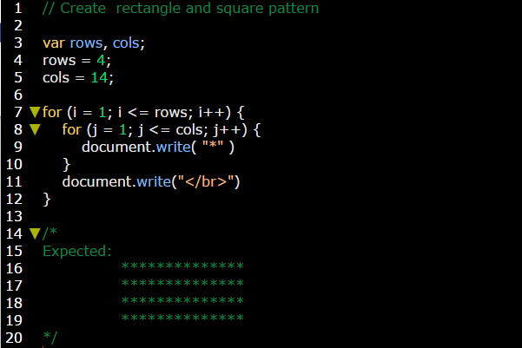

**Example:** on square pattern:

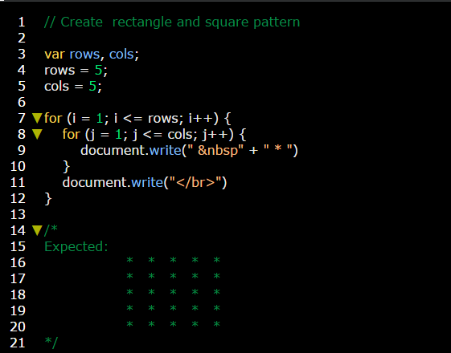

**Example:** on pyramid pattern:

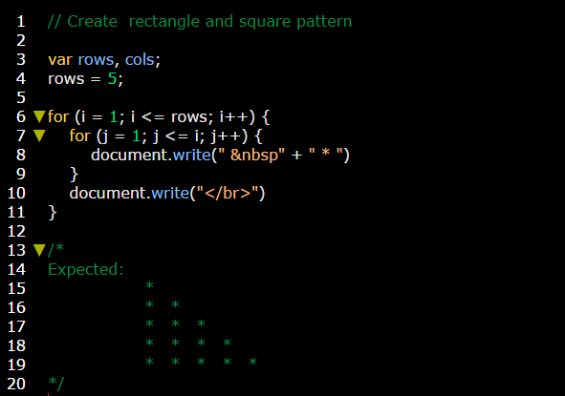

**Example:** on pyramid pattern:

